**PO2EBL_ELECTRIC BLENDER**

**CDD DOCUMENT**

**Version 1.3**

**Proposed**

# Document Status

|  |  |  |  |
| --- | --- | --- | --- |
| **Date** | **Version** | **Document Status** | **Author** |
| 03/06/2020 | 1.3 | Proposed | May Alaa |

# Document History

|  |  |  |  |
| --- | --- | --- | --- |
| Version | Date | Author | Change |
| 1 | 02/03/20 | May Alaa | Initial Creation |
| 1.1 | 03/03/20 | Mohamed Ibrahem | Adding switch flow chart |
| 1.2 | 03/05/20 | Mohamed Ibrahem | Adding table of references and updating table of requirements format and the configuration |
| 1.3 | 03/06/20 | May Alaa | Adding Coverage for the requirements |

Contents

Document Status 2

Document History 3

Table of figures: 4

Introduction 4

1.1 Project Description 4

1.2 Block diagram 5

Software Context Diagram 6

Requirements 7

Configurations 9

Reference table: 11

# Table of figures:

Figure 1 Block Diagram 5

Figure 2 Software Context Diagram 6

# Introduction

## 1.1 Project Description

The Electric Blender System is an appliance created by KENOVO. The electric blender system has 3 speeds that can be configured by the user with high safety to avoid system failure caused by unexpected voltage peaks.

## 1.2 Block diagram

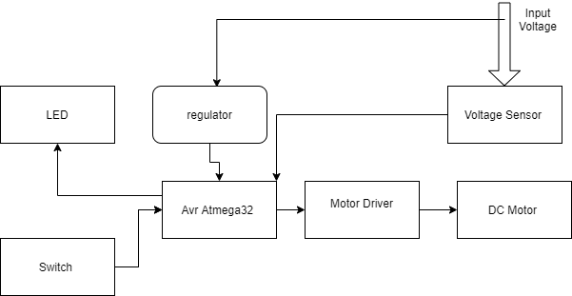

Figure 1 Block Diagram

# Software Context Diagram

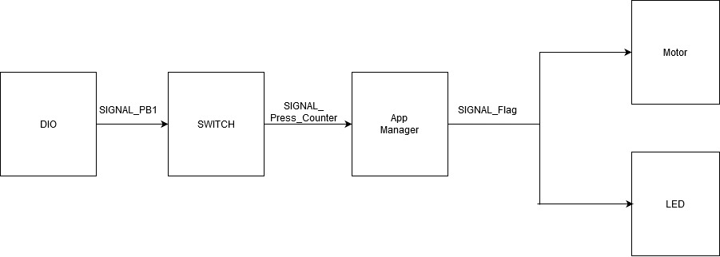

Figure 2 Software Context Diagram

# Requirements

|  |  |  |  |  |
| --- | --- | --- | --- | --- |
| **SWITCH** | | | | |
| Requirement ID | REQ_PO2EBL_CDD_1_V01 | | | |
| Covers | REQ_PO2EBL_GDD_4_V01  REQ_PO2EBL_GDD_14_V01 | | | |
| API | Parameters | | Return values | Description |
| Error_S Switch_Init(u8 Switch_Ch_No); | u8Switch_Ch_No: Denotes the Switch to be initialized | | Error_S:Standard Error  OK: If execution happened successfully  NOK: If Execution failed | This API shall Initialize a switch given the switch’s channel number |
| Implementation | | | | |
|  | | | | |
| Requirement ID | | REQ_PO2EBL_CDD_2_V01 | | |
| Covers | | REQ_PO2EBL_GDD_5_V01  REQ_PO2EBL_GDD_15_V01 | | |
| API | | Parameters | Return values | Description |
| Error_S Switch_Read(u8 Switch_Ch_No); | u8 Switch_Ch_No: Denotes the Switch whose status is s to be read | | Error_S:Standard Error  OK: If execution happened successfully  NOK: If Execution failed | This API shall read a switch’s status given the switch’s channel number |
| Implementation | | | | |
|  | | | | |

# Configurations

|  |  |
| --- | --- |
| Name | SWITCH_CONFIG |
| Types | Structure |
| Element | SWITCH_PORT  SWITCH_PIN  SWITCH_TYPE |
| Description | This structure contains the configuration parameters of the switch related to the port, pin and type. |

|  |  |
| --- | --- |
| Name | SWITCH_PORT |
| Types | Macro |
| Range | ‘A’,’B’,’C’,’D’ |
| Description | This macro define the switch’s port. |

|  |  |
| --- | --- |
| Name | SWITCH_PIN |
| Types | Macro |
| Range | 0-7 |
| Description | This macro define the switch’s pin. |

|  |  |
| --- | --- |
| Name | SWITCH_TYPE |
| Types | Macro |
| Range | PULL_UP ->1  PULL_DOWN ->2 |
| Description | This macro define connection type from pull up or pull down. |

|  |  |
| --- | --- |
| Name | SWITCH_STATE |
| Types | Enum |
| Range | SWITCH_PRESSED  SWITCH_NOT_PRESSED |
| Description | This enum indicate the switch’s state . |

# Reference table:

|  |  |  |  |
| --- | --- | --- | --- |
| **ID** | **Version** | **Document** | **Status** |
| 1 | 2.2 | SRS | Released |
| 2 | 1.5 | GDD | Proposed |